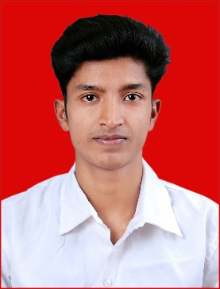**VISHNU SIVAN**

UDICHAMUKALEL (H)

ATHIRAMPUZHA P.O.

KOTTAYAM

PIN 686562

Mob: +91-9645931819, 6282352841

E-mail: [vishnusivan45@gmail.com](mailto:vishnusivan45@gmail.com)

**OBJECTIVE**

To pursue a challenging career in a reputed company, where my skills & knowledge can be enhanced to their maximum potential to contribute the overall success of the organisation.

**EDUCATIONAL QUALIFICATION**

1. **High School Studies : S.S.L.C.**

* Institute : Vivekananda public school
* Board/ University : Board Exam
* Year of Passing : March 2013
* Result. :. 68%

1. **Higher Secondary : H.S.E**

* **Subjects : Science**
* Institute : Govt. HSS Kadapoor
* Board/ University : Board of H.S.E., Kerala
* Year of Passing : March 2015
* Result. :. 74%

1. **Graduate : Bsc**

* Subjects : **Chemistry**
* Institute : Kuriakose Elias College, Mannanam
* Board/ University : MG University, Kottayam , Kerala.
* Year of Passing : March 2015
* Result. :. 69%

1. **Post Graduate** : **Msc**

* **Subject : Chemistry**
* **Institute. :** St. Stephens College, Uzhavoor
* **Board/University :** MG University, Kottayam, Kerala
* Year of Passing : March 2020
* Result. :. Awaiting

**KEY SKILLS**

* Communication skills
* Leadership
* Problem solving
* Excellent knowledge of chemicals.
* Good command over use of chemicals.
* Practical knowledge of chemical testing.
* Can take quick actions as required.
* Maintain safe and clean environment.
* Aware about the safety rules while using chemicals.
* Excellent in Equipment handling.
* Expert in Performing test.
* Good in measurements and readings.

**STRENGHTS**

* Independent and self motivated.
* Strong communication and interpersonal skills.
* Ability to work in team as well as independently.
* Good Responsibility.
* Hard Working.
* Punctual.

**PERSONAL DETAILS**

Name : Vishnu Sivan

Address : Udichamukalel (H)

Athirampuzha P.O.

Kottayam

Pin 686562

Date of birth : 01/07/1996

Age : 24

Gender : Male

Father’s name : Sivan

Nationality : Indian

Marital status : single

Languages known : English, Malayalam, Tamil, Hindi

Hobbies : Reading, Driving, Swimming, Listening music

Contact no. : 9645931819, 6282352841

**DECLERATION**

I hereby declare that all the information stated above is true to the best of my knowledge and belief**.**

Place: Athirampuzha

Date: 15/05/2021 **VISHNU SIVAN**